# VARIABLES IN C++

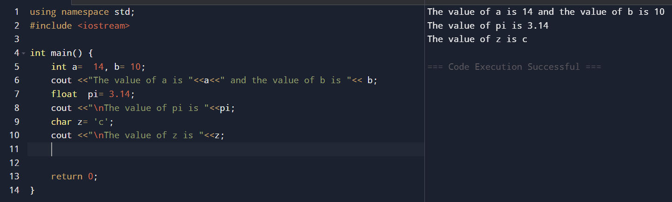

# Task 01:

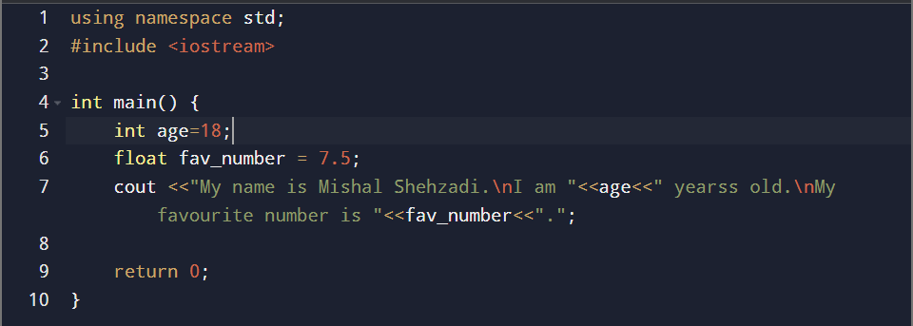

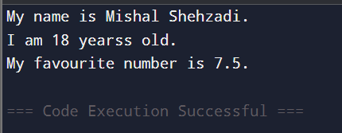

# Task 02:

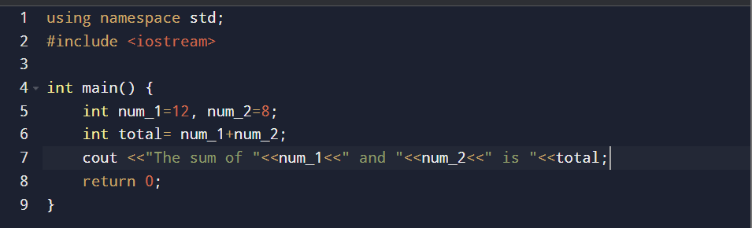

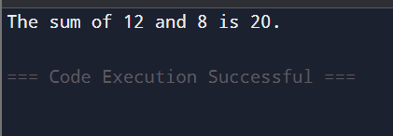

# Task 03:

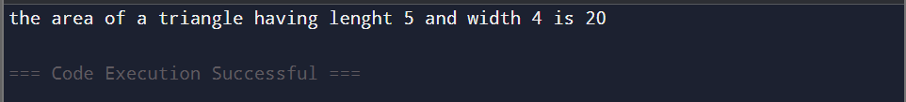

# Test 01:

# Test 02:

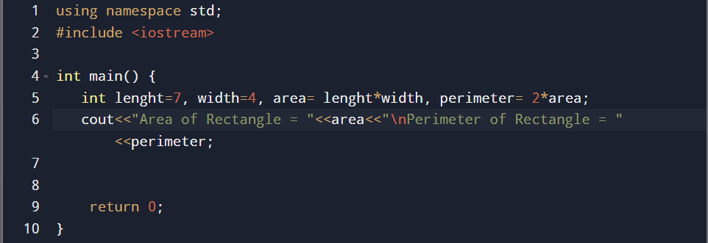

# Test 03:

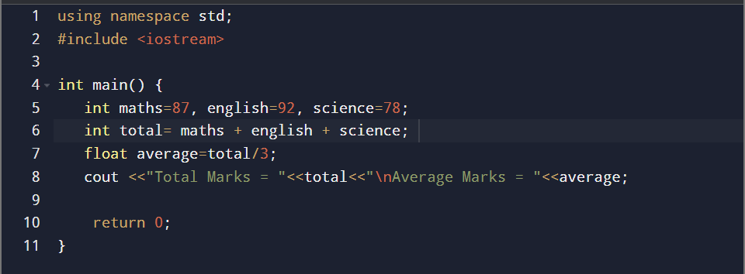

# Test 04:

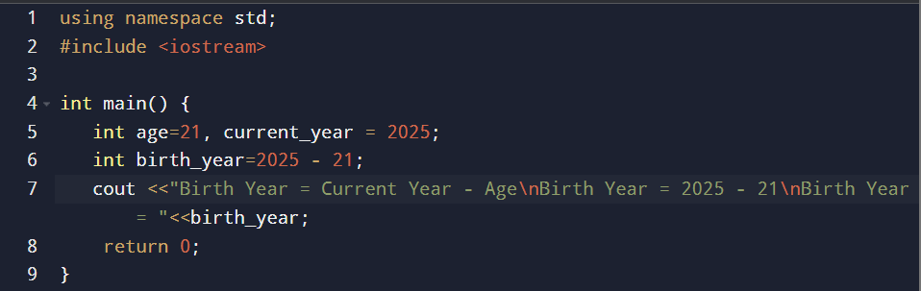

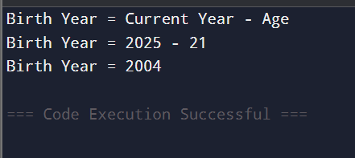

# Test 05:

